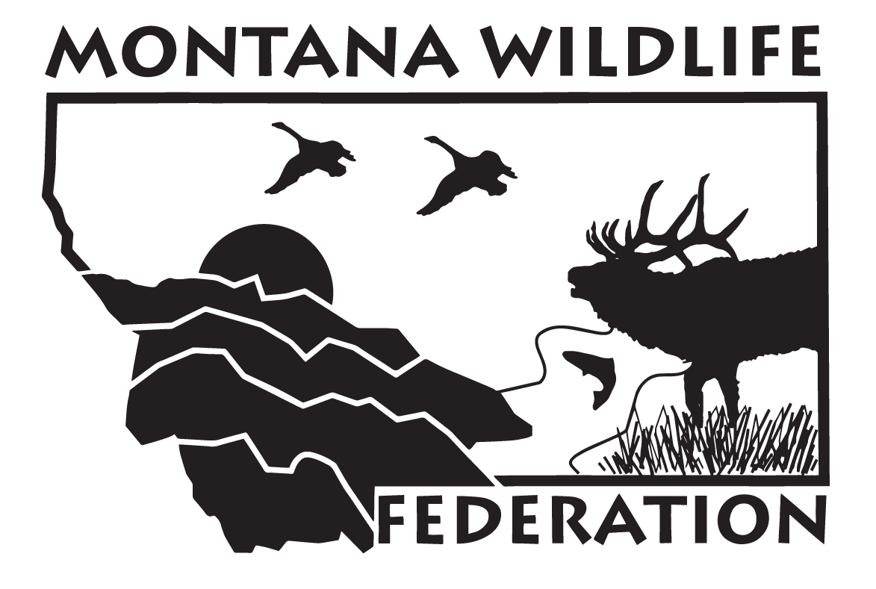
PHIL TAWNEY
HUNTERS CONSERVATION ENDOWMENT

PROGRAM GUIDELINES

Endowment Mission Statement
To educate and inform the general public about hunting ethics, fair chase, and values; to perpetuate the sport of the hunt through efforts to conserve habitat and wildlife; and to stimulate the recruitment, mentoring, and involvement of youth in hunting and conservation activities.

Program Guidelines
The Phil Tawney Hunters Conservation Endowment is especially concerned about the long-term effects of private and public actions on our public resources. The Endowment values organizations that are grounded in democratic principles with memberships that reflect the diversity of their communities.

While recognizing that organizations employ a range of strategies to address public resource issues, the Endowment gives special attention to efforts that organize and involve local citizens. The Endowment also encourages collaboration between local groups and regional or national organizations on projects that promote public education, involvement, and advocacy. In keeping with the spirit of Phil’s legacy, the Phil Tawney Hunters Conservation Endowment offers a one-year grant to a 501(c)(3) organization with a proposed project that exhibits a similar commitment to our outdoor heritage.

The Endowment seeks projects that emphasize one or more of the following:
- The interface between hunting and wildlife management, especially as issues affect children;
- Strategies to promote environmentally healthy wildlife habitat;
- Public policy changes to improve conservation and habitat;
- Strategies to improve and promote hunting ethics, fair chase, values, and safety; and
- Activities to stimulate the recruitment, mentoring and involvement of youth in hunting and conservation activities.

APPLICATION PROCEDURE
Submit one application including the Application Cover Sheet (following page) and Project Description (see guidelines), and one (1) copy of an IRS 501(c)(3) verification letter. Applications must be postmarked by April 15, 2016.

Mail application packets via the US Postal Service to the following address:

Phil Tawney Hunters Conservation Endowment
c/o Montana Wildlife Federation
P.O. Box 1175
Helena, MT 59624-1175
Applications sent via Federal Express or UPS are undeliverable. Email applications will not be considered.
APPLICATION DETAIL

Project Description
Submit a separate Project Description of no more than two (2) pages in length, attached to the Application Cover Sheet, and include a budget (between $500 - $5,000) and a brief description of the project, the project’s goals and expected outcomes, plans to evaluate the project’s success, and how the project fulfills the mission of the Phil Tawney Hunters Conservation Endowment.

Please follow formatting instructions carefully.
- The Project Description should be typed, using a 12-point easy-to-read type font, on white paper, no more than two single-sided pages in length.
- Send no attachments, other than verification of exemption under IRS Section 501(c) (3), or, if the applicant is not exempt, verification of a 501(c) (3) fiscal agent.
- Your Application Cover Sheet must be signed and dated by an officer of the organization’s board.

Time Frame
Submittal Deadline: April 15, 2016 (Proposals must be postmarked on or before this date).

Accepting an award from the Phil Tawney Hunters Conservation Endowment obligates you to provide:
- A semi-annual project evaluation and financial report, mailed to the Endowment; including photos if available. Include in this report a narrative summarizing project success or failure to obtain the goals of the project.
- Onsite visits and interviews, when deemed appropriate, by Endowment board and/or staff;
- Written acknowledgment of the endowment as a funding agent in any public announcements or publications concerning the funded project;
- A signed Grant Agreement detailing the terms of the award; and
- Permission to publish information about your project in the Endowment’s public announcements or publications and MWF publications.

For additional information, contact Dave Chadwick at (800) 517-7256 or email: dchadwick@mtwf.org or visit our web site at: www.montanawildlife.org.

PHIL TAWNEY
Hunters Conservation Endowment Grant
APPLICATION COVER SHEET
This form must accompany your proposal, which must be postmarked by April 15, 2016.
Please type or print, using black or blue ink. Only complete and legible applications will be accepted.

Organization Name: _____________________________________________________________
Address:_______________________________________________________________________
City, State, Zip: _________________________________________________________________
Contact Person:__________________________________________________________________
Address (if different than above):____________________________________________________
City, State, Zip: __________________________________________________________________
Phone #: _____________________________ Fax #: ____________________________________
Email Address: __________________________________________________________________
PROJECT SUMMARY
Project title: _________________________________________________________________
Project Period: Start date: ______________ Completion date: _____________
ORGANIZATION DESCRIPTION AND/OR APPLICANT RESUME
_____________________________________________________________________________________
_____________________________________________________________________________________
__________________________________________________________________________________________________________________________________________________________________________
Total grant request: $ _________ Total matching funds: $ ________ Total project budget: $ ___________
Please specify any other funding sources to which you have applied for or received monies for this project and/or how much has been committed.
_____________________________________________________________________________________
__________________________________________________________________________________________________________________________________________________________________________
Please check one of the following:
_____ 501(c) (3) (IRS verification letter REQUIRED) or
_____ Exempt Governmental Unit (specify/verification REQUIRED) _____________________________
_____ Other (please specify) ______________________________________________________________
Signature: _________________________ Title: ________________________ Date:___________
Send one copy of the Application Cover Sheet, project narrative, and one copy of IRS tax exemption letter with a postmark no later than April 15, 2016 to:
Montana Wildlife Federation
P.O. Box 1175
Helena, MT 59624-1175

